For the Skype issue over MSFT VPN please do the following steps.

1. Open Control panel (Press Win + R →  type “Control” → press Enter) or (Just search Control Panel in start menu and click on it.

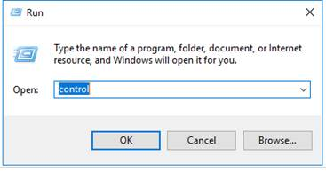

1. In control panel search for Windows Defender firewall



1. After opening windows defender firewall click on “Advance settings”

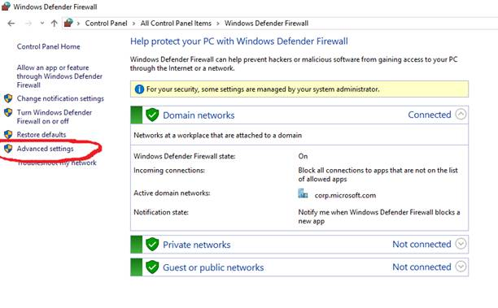

1. Then click on Outbound rules → Search for MSIT Skype over VPN → Select all of them → then click on disable rule.

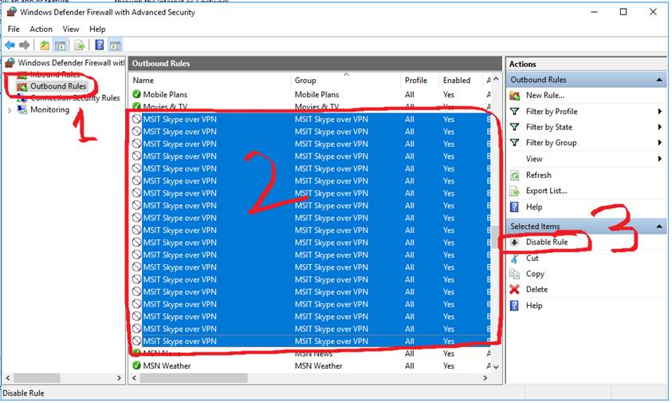

1. After this please disconnect another VPN (If connected) and connect to MSFT VPN then check the status of skype and internet.
2. If still issue persists, please reboot your system once then check after connecting the MSFT VPN. (Sometimes Reboot required for changing the firewall rule).
3. If “MSIT Skype over VPN” profile is not there in your system, please import the rules by running this Reg Key from Skype_rule.reg in the below share \\fsu\shares\seot3\T3CustomerLogs\msftvpn
4. then follow the steps from step 4.

Feel free to let me know if you have any queries.

Thank You,

Vishnu